- Check data types:
DESCRIBE proyecto1db.stock_raw_data;
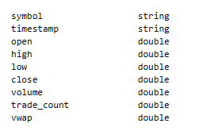
- Create a new table of type iceberg changing timestamp, and then continue on it with data cleansing and manipulation:
CREATE TABLE proyecto1db.stock_iceberg
WITH (
table_type = 'ICEBERG',
format = 'PARQUET',
is_external = false,
location = 's3://aws-ddf-pi-2025/processed/warehouse/stock_iceberg/'
) AS
SELECT
symbol,
from_iso8601_timestamp(
regexp_replace(timestamp, ' ', 'T')
) AS timestamp,
open,
high,
low,
close,
volume,
trade_count,
vwap
FROM proyecto1db.stock_raw_data;

- Check that dates are correct and there are not nulls:
SELECT
COUNT(*) AS total_rows,
COUNT_IF(timestamp IS NULL) AS null_timestamps,
COUNT_IF(TRY_CAST(timestamp AS TIMESTAMP) IS NULL) AS invalid_timestamps
FROM proyecto1db.stock_iceberg;
- Add column local_timestamp and populate with new York time zone:
ALTER TABLE proyecto1db.stock_iceberg ADD COLUMNS (local_timestamp timestamp);
UPDATE proyecto1db.stock_iceberg
SET local_timestamp = CAST(
REPLACE(
CAST((timestamp AT TIME ZONE 'UTC') AT TIME ZONE 'America/New_York' AS VARCHAR),
'America/New_York',
''
) AS TIMESTAMP
);
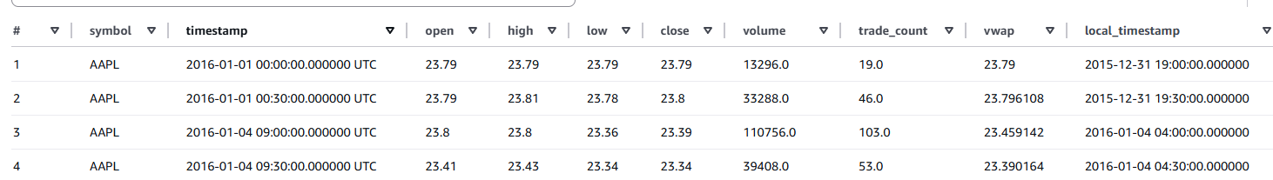

- Lookup for the max and min dates to check it corresponds to what was queried:
SELECT
MIN(local_timestamp) AS min_date,
MAX(local_timestamp) AS max_date
FROM proyecto1db.stock_iceberg;

- Remove dates lower than 2016-01-01:
DELETE FROM proyecto1db.stock_iceberg
WHERE local_timestamp < TIMESTAMP '2016-01-01 00:00:00';

- Check that all symbols match the stock market criteria for Tickers:
SELECT DISTINCT symbol
FROM proyecto1db.stock_iceberg
WHERE
symbol IS NULL
OR symbol = ''
OR regexp_like(symbol, '[^A-Z]') -- anything not A–Z
OR length(symbol) > 5;
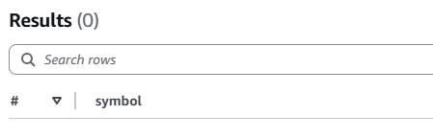

- Check for inconsistencies in value columns:
SELECT
-- OPEN
SUM(CASE WHEN open IS NULL THEN 1 ELSE 0 END) AS open_nulls,
SUM(CASE WHEN open < 0 THEN 1 ELSE 0 END) AS open_negative,
-- HIGH
SUM(CASE WHEN high IS NULL THEN 1 ELSE 0 END) AS high_nulls,
SUM(CASE WHEN high < 0 THEN 1 ELSE 0 END) AS high_negative,
-- LOW
SUM(CASE WHEN low IS NULL THEN 1 ELSE 0 END) AS low_nulls,
SUM(CASE WHEN low < 0 THEN 1 ELSE 0 END) AS low_negative,
-- CLOSE
SUM(CASE WHEN close IS NULL THEN 1 ELSE 0 END) AS close_nulls,
SUM(CASE WHEN close < 0 THEN 1 ELSE 0 END) AS close_negative,
-- VOLUME
SUM(CASE WHEN volume IS NULL THEN 1 ELSE 0 END) AS volume_nulls,
SUM(CASE WHEN volume < 0 THEN 1 ELSE 0 END) AS volume_negative,
-- TRADE_COUNT
SUM(CASE WHEN trade_count IS NULL THEN 1 ELSE 0 END) AS trade_count_nulls,
SUM(CASE WHEN trade_count < 0 THEN 1 ELSE 0 END) AS trade_count_negative,
-- VWAP
SUM(CASE WHEN vwap IS NULL THEN 1 ELSE 0 END) AS vwap_nulls,
SUM(CASE WHEN vwap < 0 THEN 1 ELSE 0 END) AS vwap_negative
FROM proyecto1db.stock_iceberg;
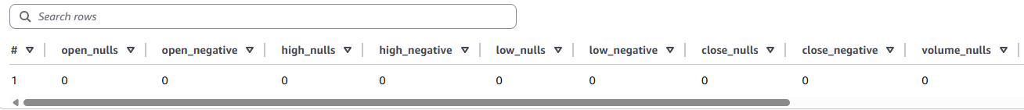
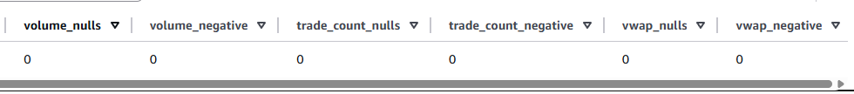

- Check for incongruent values in value columns:
SELECT
-- 1️⃣ Low higher than High
SUM(CASE WHEN low > high THEN 1 ELSE 0 END) AS low_higher_than_high,
-- 2️⃣ Open below Low
SUM(CASE WHEN open < low THEN 1 ELSE 0 END) AS open_below_low,
-- 3️⃣ Open above High
SUM(CASE WHEN open > high THEN 1 ELSE 0 END) AS open_above_high,
-- 4️⃣ Close below Low
SUM(CASE WHEN close < low THEN 1 ELSE 0 END) AS close_below_low,
-- 5️⃣ Close above High
SUM(CASE WHEN close > high THEN 1 ELSE 0 END) AS close_above_high,
-- 6️⃣ VWAP outside (low, high)
SUM(CASE WHEN vwap < low OR vwap > high THEN 1 ELSE 0 END) AS vwap_outside_range,
-- 7️⃣ Zero or negative volume
SUM(CASE WHEN volume < 0 THEN 1 ELSE 0 END) AS negative_volume,
-- 8️⃣ Zero or negative trade_count
SUM(CASE WHEN trade_count <= 0 THEN 1 ELSE 0 END) AS zero_or_negative_trade_count
FROM proyecto1db.stock_iceberg;

- Handling vwap_outside_range:
SELECT
symbol,
local_timestamp,
open,
high,
low,
close,
volume,
trade_count,
vwap,
CASE
WHEN vwap < low THEN 'below_low'
WHEN vwap > high THEN 'above_high'
ELSE 'ok'
END AS vwap_issue
FROM proyecto1db.stock_iceberg
WHERE vwap < low OR vwap > high
ORDER BY close desc;
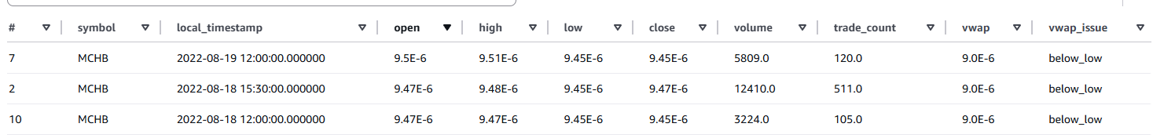
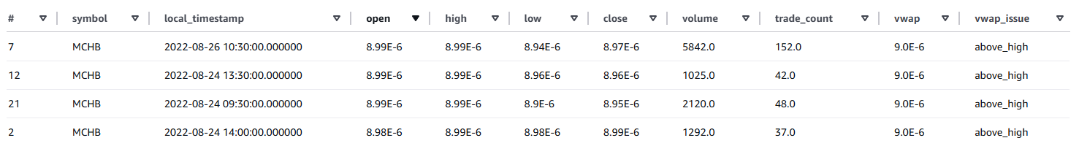

The above shows it is a rounding issue for very small values. Therefore the solution established is to assign a value in the middle of high and low for these cases.
UPDATE proyecto1db.stock_iceberg
SET vwap = (low + high) / 2
WHERE vwap < low OR vwap > high;
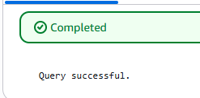
Checking again:
